**Azure App Services**

1. Deploy a HTML Web Application in Azure App Services

2. Host the App Services in the Virtual Machine deployed

Azure App Service enables you to build and host web apps, mobile back ends, and RESTful APIs in the programming language of your choice without managing infrastructure. It offers auto-scaling and high availability, supports both Windows and Linux, and enables automated deployments from GitHub, Azure DevOps, or any Git repo.

Used the same resource group and region (which was already created) to create the services. Below screen shots shows the how to create the App services and deploying the HTML application in azure app services.

Go to App Services and select the select Create App service if it is first time or select the Add option.

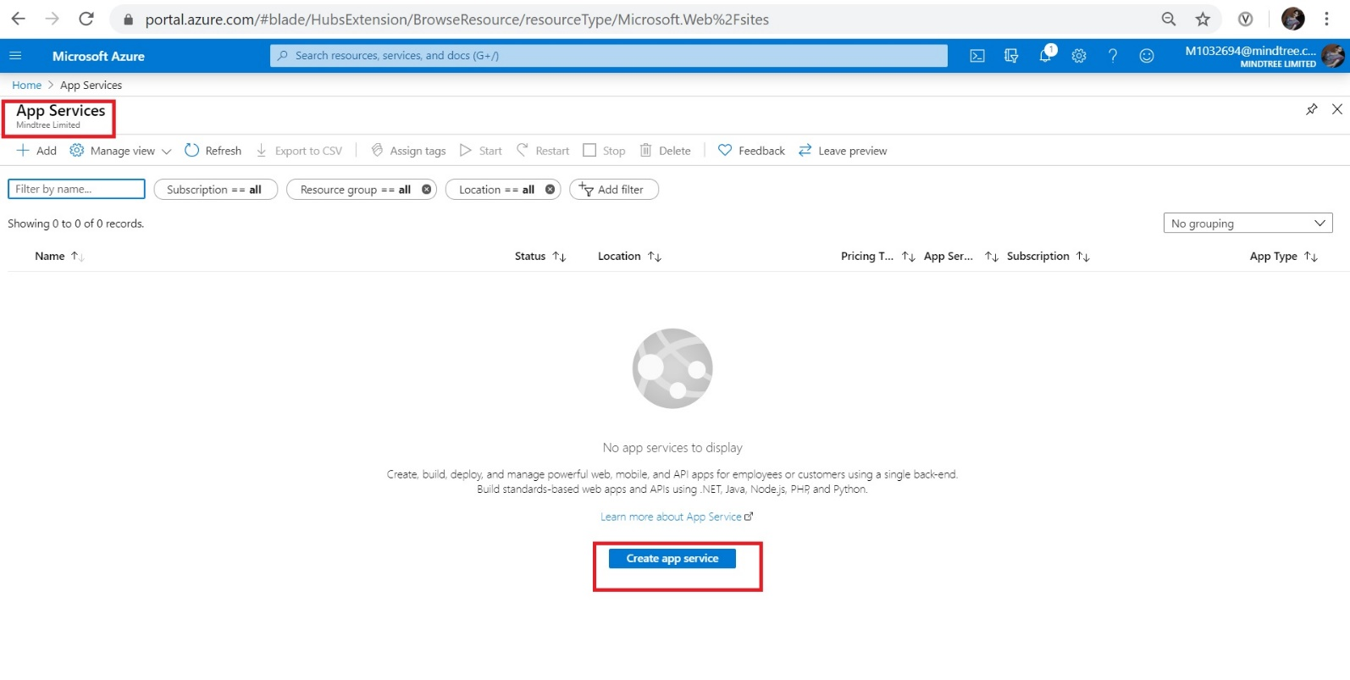

Fill all the required details, select the button Review and create.

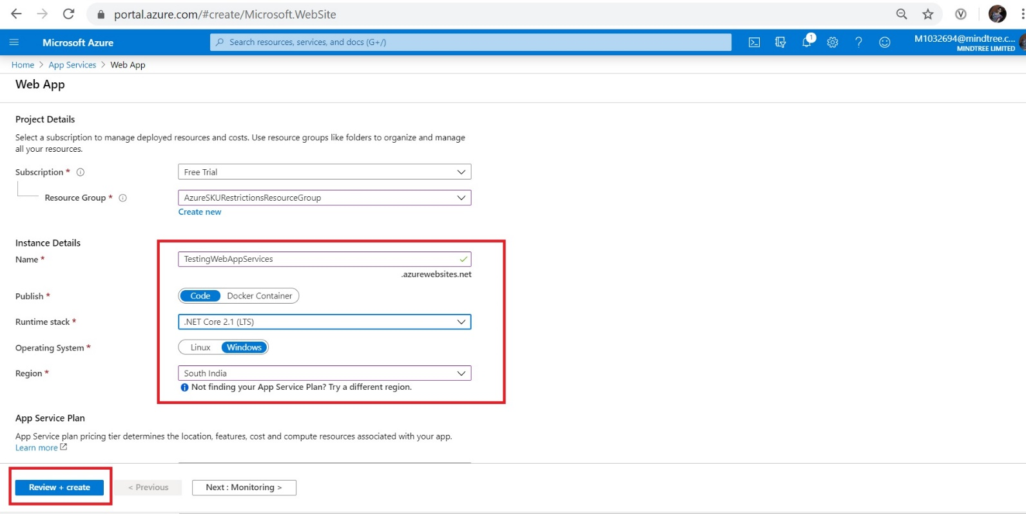

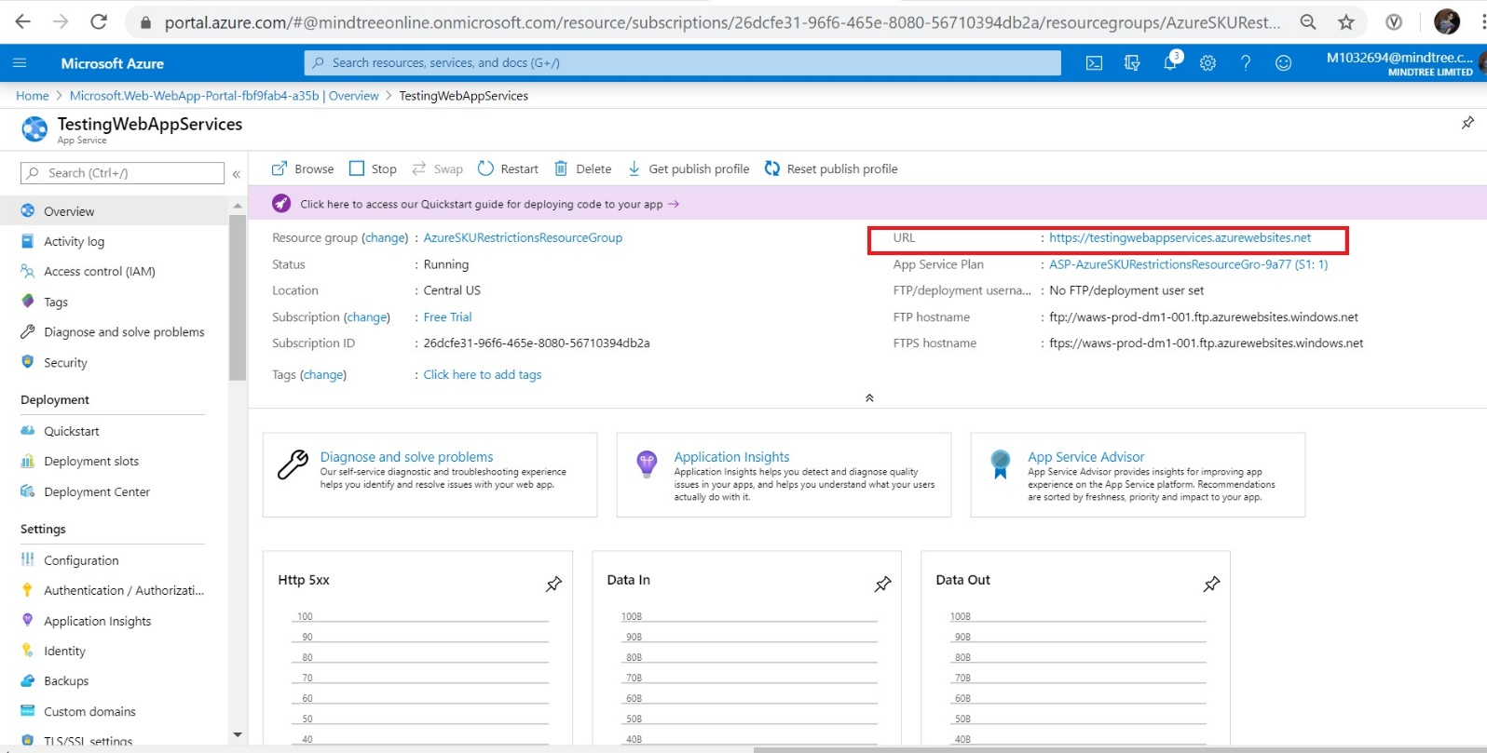

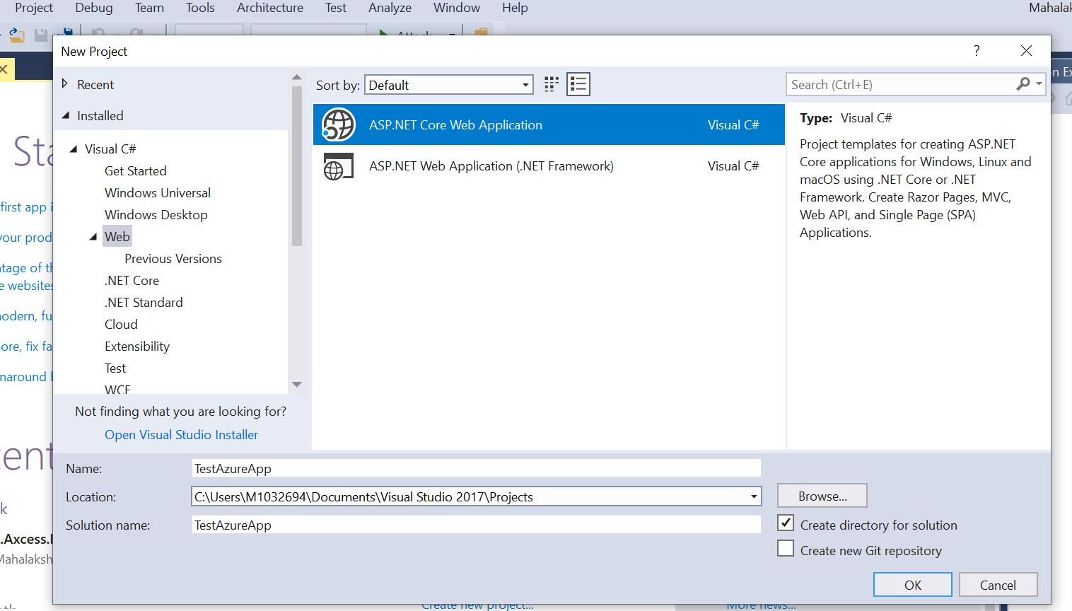

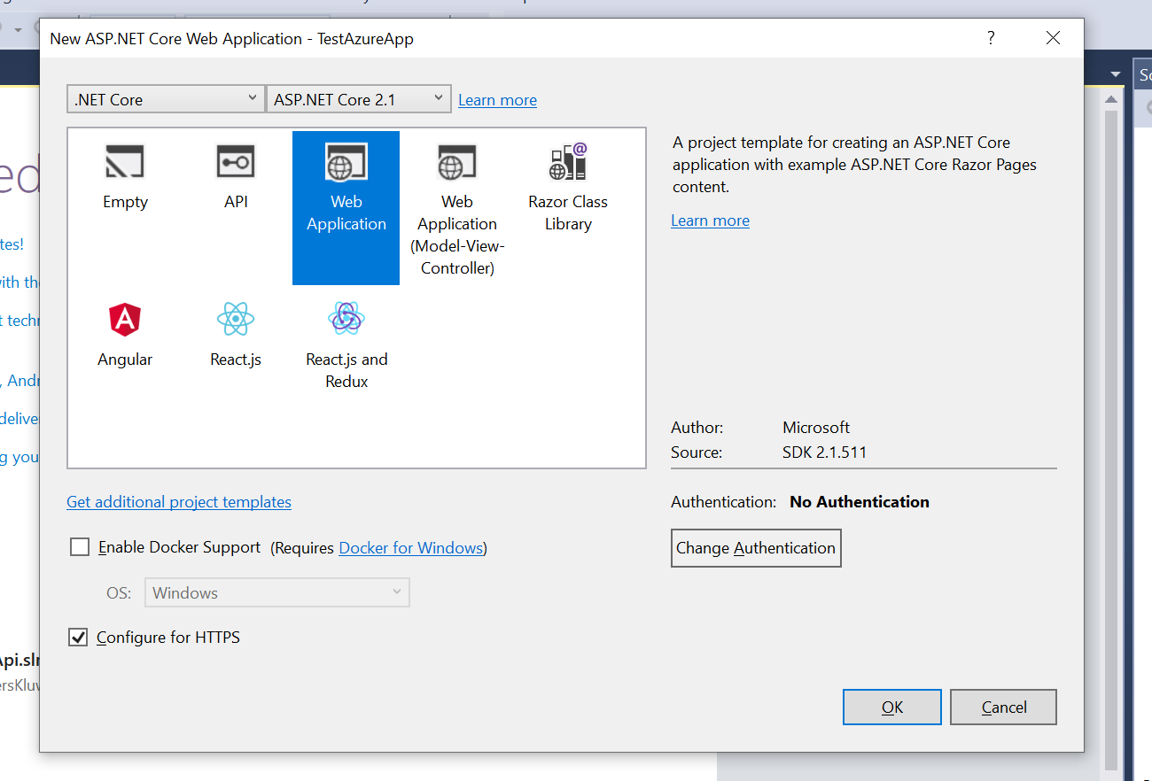

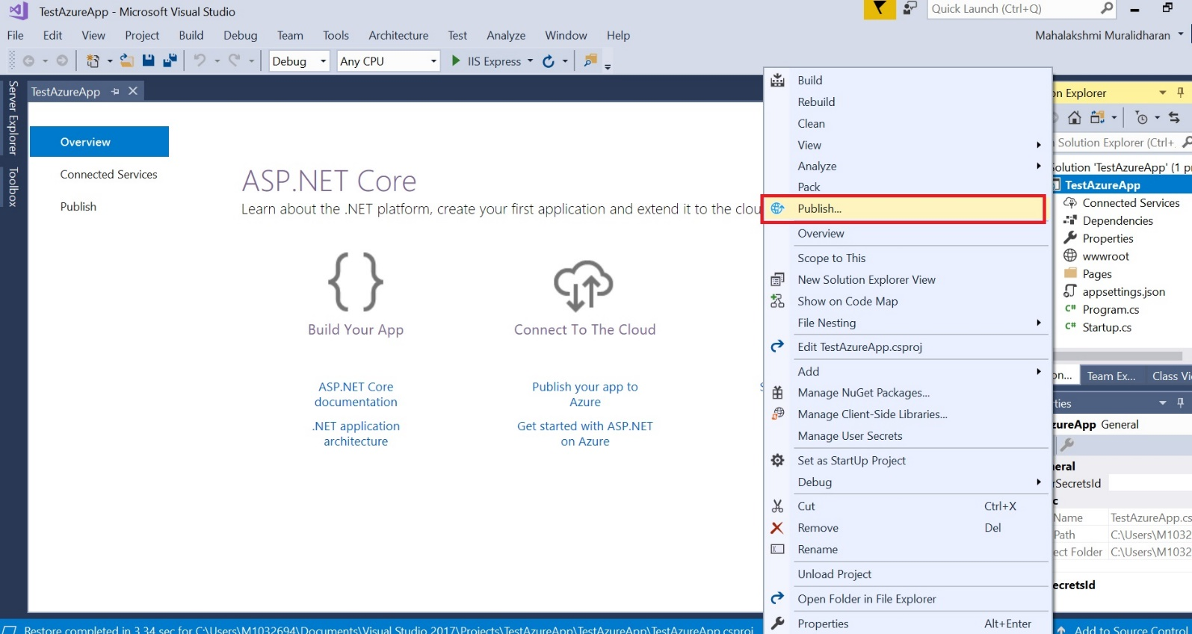

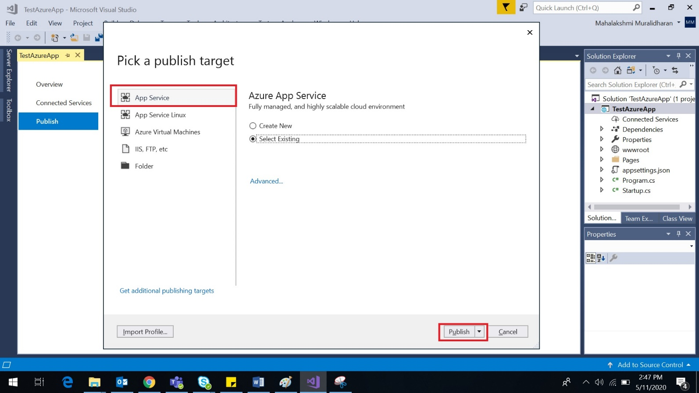

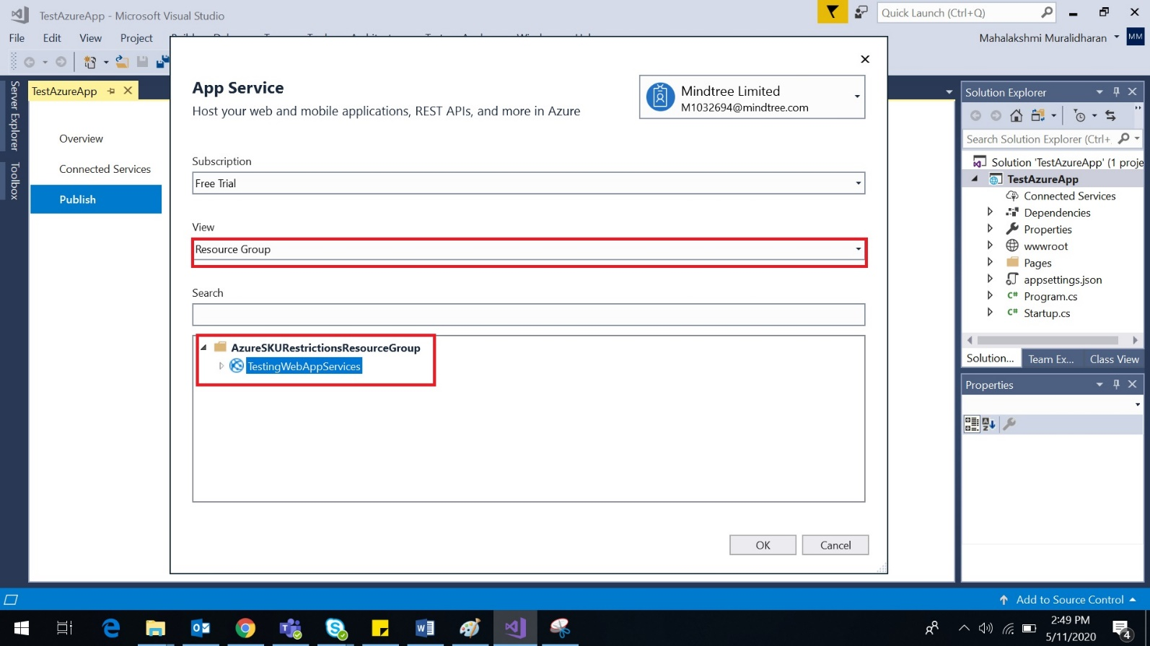

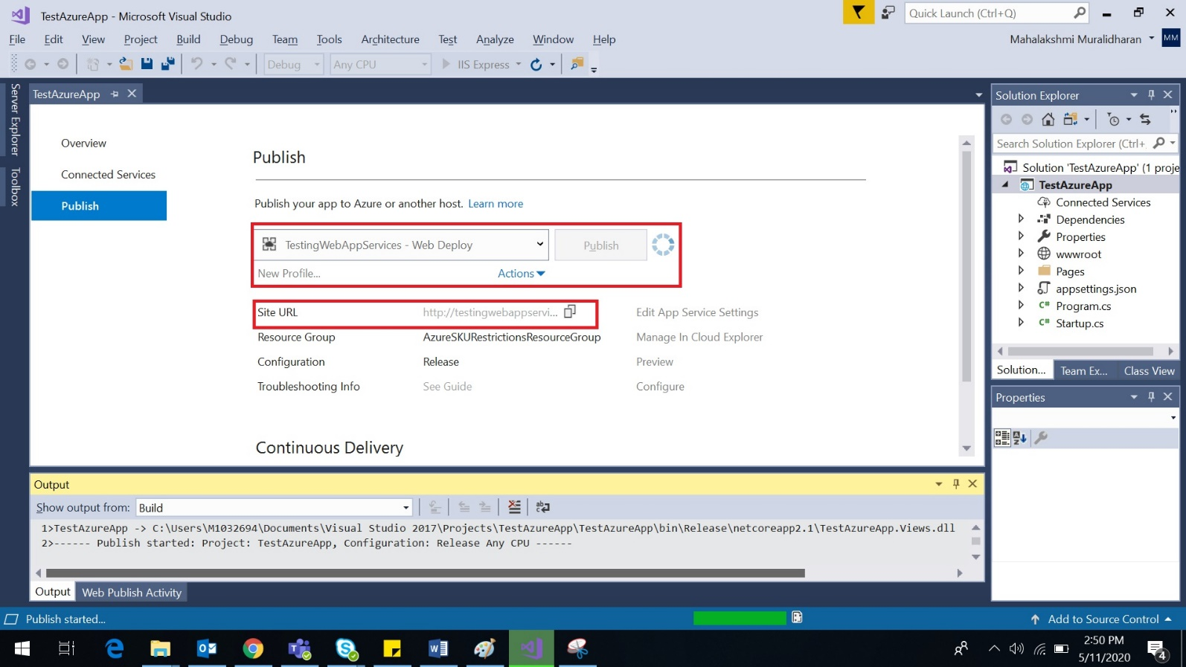

Please find the below url to access the HTML application deployed in the app services

<http://testingwebappservices.azurewebsites.net>

